NOTICE:
Effective 1/1/2023, we do not accept empty containers at this location.

Empty containers can be redeemed at the nearest redemption center:

[Redemption Center Name]
[Redemption Center Address]

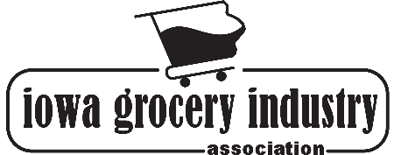
Pursuant to Iowa Senate File 2378 – Bottle Bill

